**Project Report**

**1. INTRODUCTION**

1.1 Project Overview

1.2 Purpose

**2. IDEATION PHASE**

2.1 Problem Statement

2.2 Empathy Map Canvas

2.3 Brainstorming

**3. REQUIREMENT ANALYSIS**

3.1 Customer Journey map

3.2 Solution Requirement

3.3 Data Flow Diagram

3.4 Technology Stack

**4. PROJECT DESIGN**

4.1 Problem Solution Fit

4.2 Proposed Solution

4.3 Solution Architecture

**5. PROJECT PLANNING & SCHEDULING**

5.1 Project Planning

**6. FUNCTIONAL AND PERFORMANCE TESTING**

6.1 Performance Testing

**7. RESULTS**

7.1 Output Screenshots

**8. ADVANTAGES & DISADVANTAGES**

**9. CONCLUSION**

**10. FUTURE SCOPE**

**11. APPENDIX**

GitHub & Project Demo Link

**1.INTRODUCTION**

**1.1 Project Overview:**

LearnHub – Seamless Enrollment Booking for Health is a full-stack web application designed to simplify and digitize the process of enrolling learning enrollments between students and healthcare providers. Traditional enrollment enrolling methods often involve long waiting times, manual scheduling, lack of transparency, and inefficient communication between students and courses. This project aims to address these challenges by providing a centralized online platform where users can easily search for courses, check availability, and schedule enrollments in real time.

Courses can manage their schedules, confirm or reschedule enrollments, and update learning session details. Admins oversee the overall platform operations, approve course registrations, and ensure system compliance. The application follows a modern client-server architecture using React.js for the frontend, Express.js and Node.js for backend services, and MongoDB for data management.

**1.2 Purpose:**

The primary purpose of the LearnHub application is to enhance accessibility, efficiency, and convenience in healthcare enrollment scheduling through a digital solution. The project focuses on reducing manual effort, minimizing waiting times, and improving interaction between students and courses.

**Key objectives of the system include:**

* Providing an intuitive platform for users to discover healthcare professionals and book enrollments online.
* Allowing courses to efficiently manage their schedules and student requests.
* Enabling administrators to maintain system governance and ensure secure platform operations.
* Delivering real-time enrollment updates, notifications, and status tracking.
* Creating a scalable and user-friendly healthcare enrolling system using modern full-stack technologies.

Overall, the project aims to bridge the gap between students and healthcare services by offering a reliable and structured enrollment management solution that improves user experience and operational efficiency.

**2.IDEATION PHASE**

**2.1 Problem Statement:**

In today’s healthcare systems, enrolling and managing course enrollments can be time-consuming and confusing for both students and courses. Many traditional methods do not provide real-time availability or a centralized scheduling system, which leads to missed updates, overlapping requests, and user frustration. The LearnHub platform aims to solve these challenges by providing a streamlined digital solution for efficient enrollment enrolling and management.

**Problem Statement -1:**

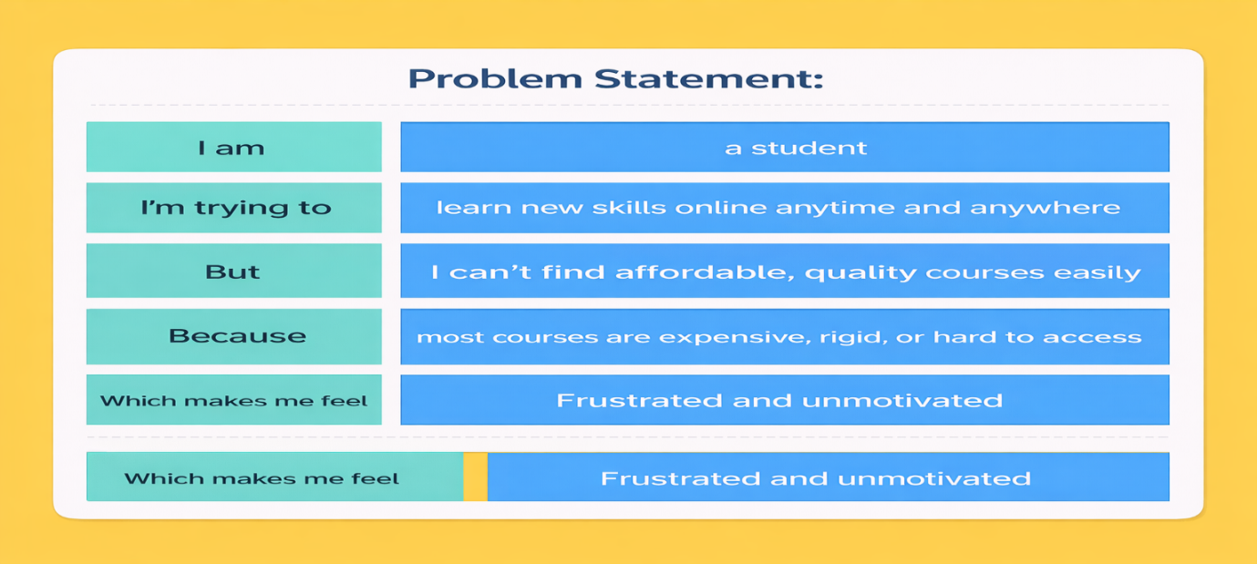

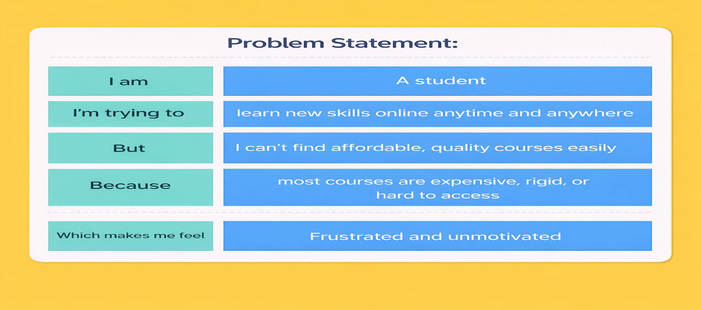**Problem** **Statement -2:**

|  |  |  |  |  |  |
| --- | --- | --- | --- | --- | --- |
| **Problem Statement (PS)** | **I am** | **I’m trying to** | **But** | **Because** | **Which makes me feel** |
| PS-1 | A student | Book a course enrollment online quickly | I cannot see real time availability clearly | Traditional enrolling systems don’t show updated slots | Anxious and frustrated |
| PS-2 | A course | Manage my daily enrollments efficiently | Requests come from multiple sources and get confusing | There is no centralized scheduling platform | Overwhelmed |

**2.2 Empathy Map:**

**User: - Student (Learner Using LearnHub)**

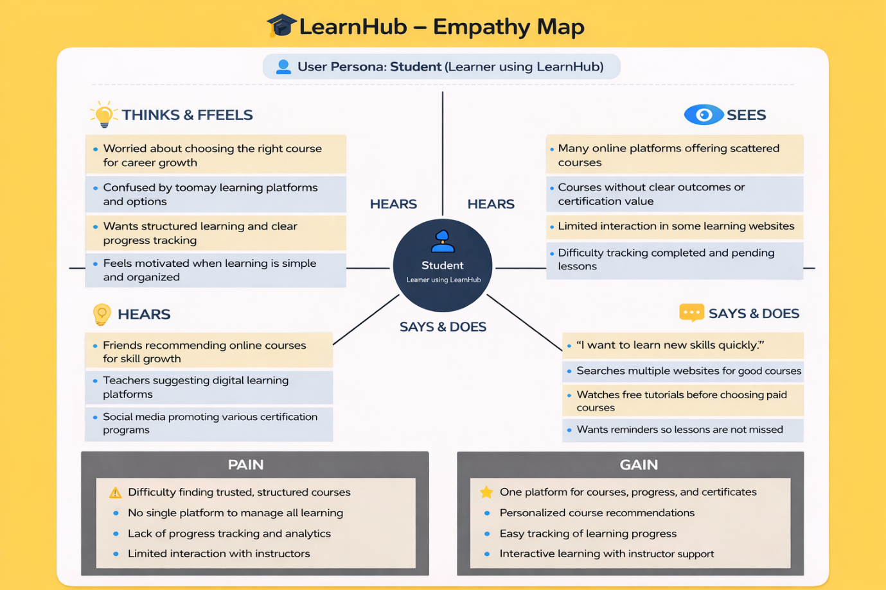

**2.2 Brainstorm & Idea Prioritization:-**

**Step-1: Team Gathering, Collaboration and Select the Problem Statement**

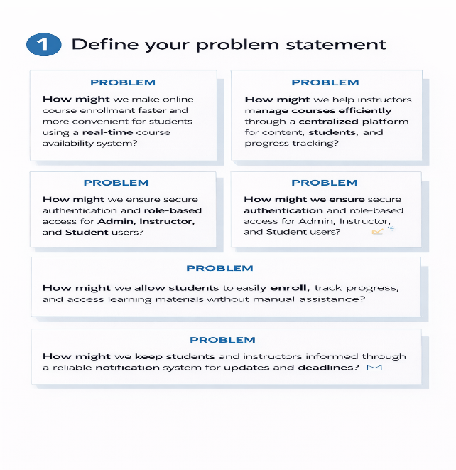

**Step-2: Brainstorm, Idea Listing and Grouping**

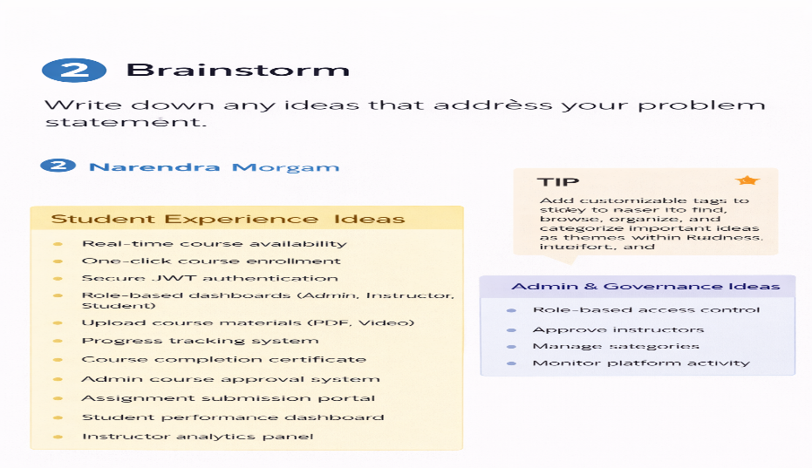

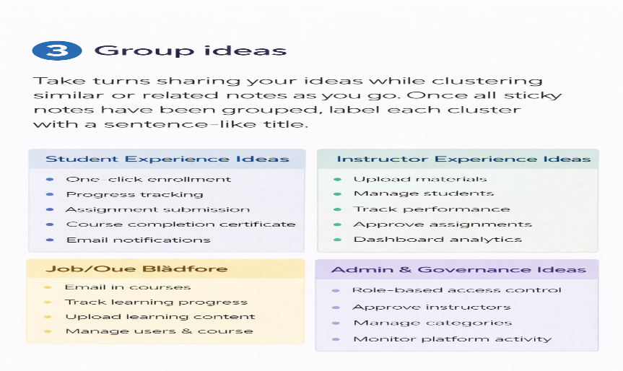

**Step-3: Idea Prioritization**

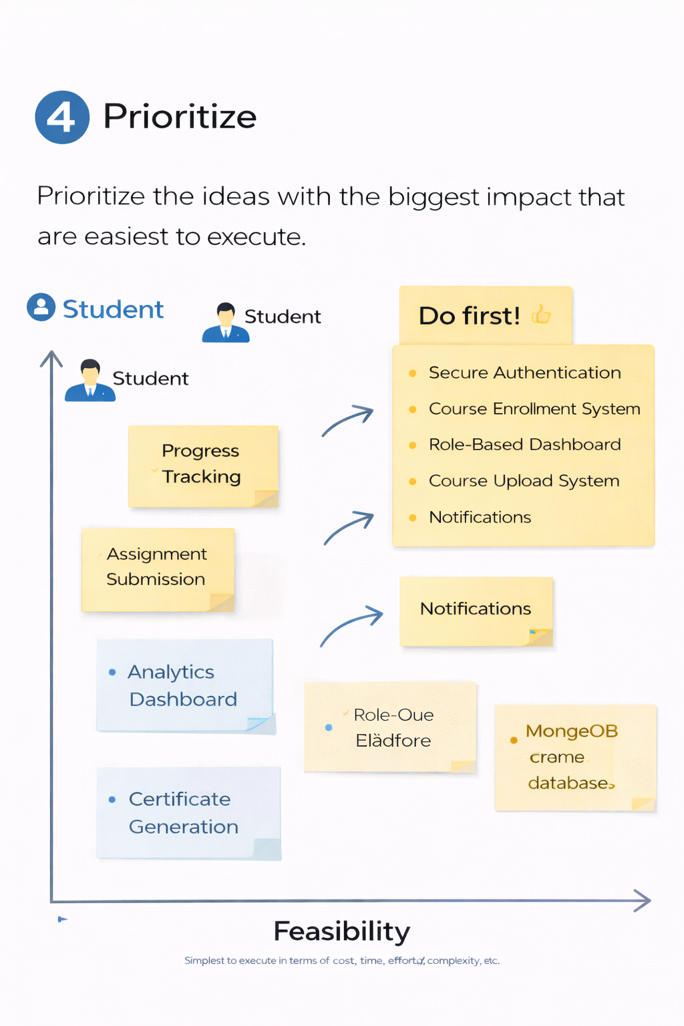

**REQUIREMENT ANALYSIS**

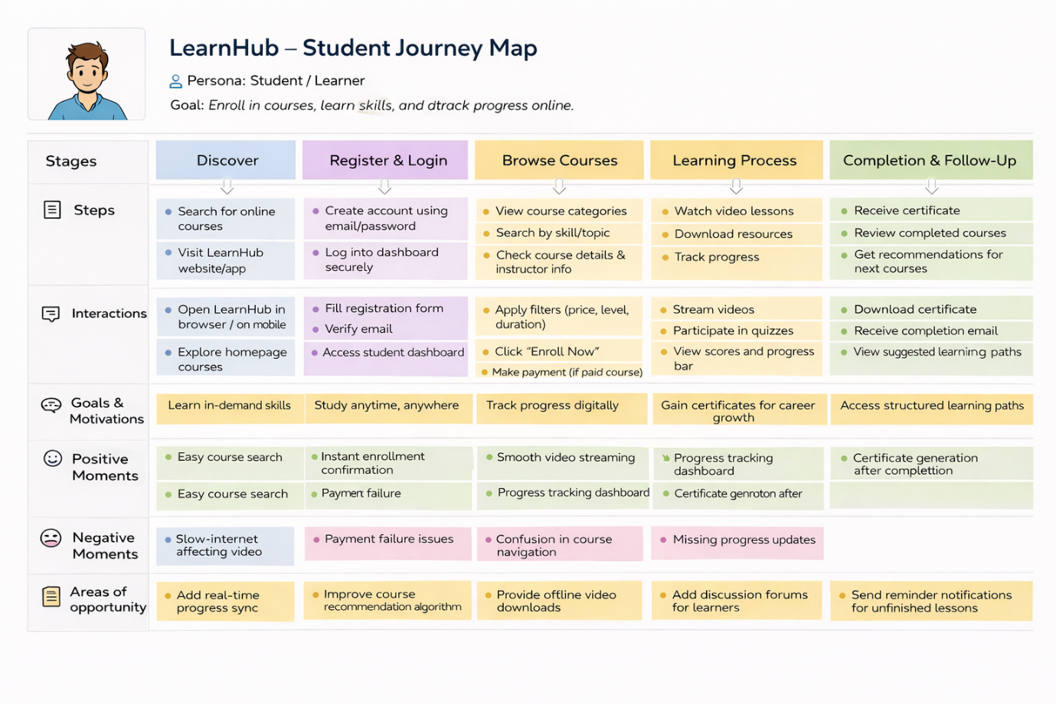**3.1 Customer Journey map:**

**3.2 Solution Requirement**

**Functional Requirements:**

Following are the functional requirements of the proposed solution.

|  |  |  |
| --- | --- | --- |
| **FR No.** | **Functional Requirement (Epic)** | **Sub Requirement (Story / Sub-Task)** |
| FR-1 | User Registration | Registration through Form Role selection (User / Course) Secure password creation |
| FR-2 | User Authentication | Login using Email & Password JWT-based authentication |
| FR-3 | Course Browsing & Search | View course list on dashboard Filter by specialization / availability |
| FR-4 | Enrollment Booking | Select date & time slot Upload learning documents Submit application request |
| FR-5 | Enrollment Management | View enrolling history Cancel or reschedule enrollment Track status (Pending / Scheduled / Completed) |
| FR-6 | Course Dashboard | View incoming enrollment requests Accept / Reject / Reschedule enrollings |
| FR-7 | Admin Governance | Approve course registrations Monitor platform activity |
| FR-8 | Notification System | User receives confirmation updates Enrollment status notifications |

**Non-functional Requirements:**

Following are the non-functional requirements of the proposed solution.

|  |  |  |
| --- | --- | --- |
| **FR No.** | **Non-Functional Requirement** | **Description** |
| NFR-1 | **Usability** | Simple and user-friendly interface allowing students to book enrollments easily without technical knowledge. |
| NFR-2 | **Security** | JWT authentication, encrypted passwords, and secure document upload to protect user data and privacy. |
| NFR-3 | **Reliability** | System ensures accurate enrollment scheduling and consistent status updates without data loss. |
| NFR-4 | **Performance** | Fast loading of dashboards and real-time enrolling actions through efficient API communication. |
| NFR-5 | **Availability** | Platform accessible online anytime for students, courses, and admins to manage enrollments. |
| NFR-6 | **Scalability** | MongoDB and REST architecture allow future expansion to more users, courses, and healthcare services. |

**3.3 Data Flow Diagram: -**

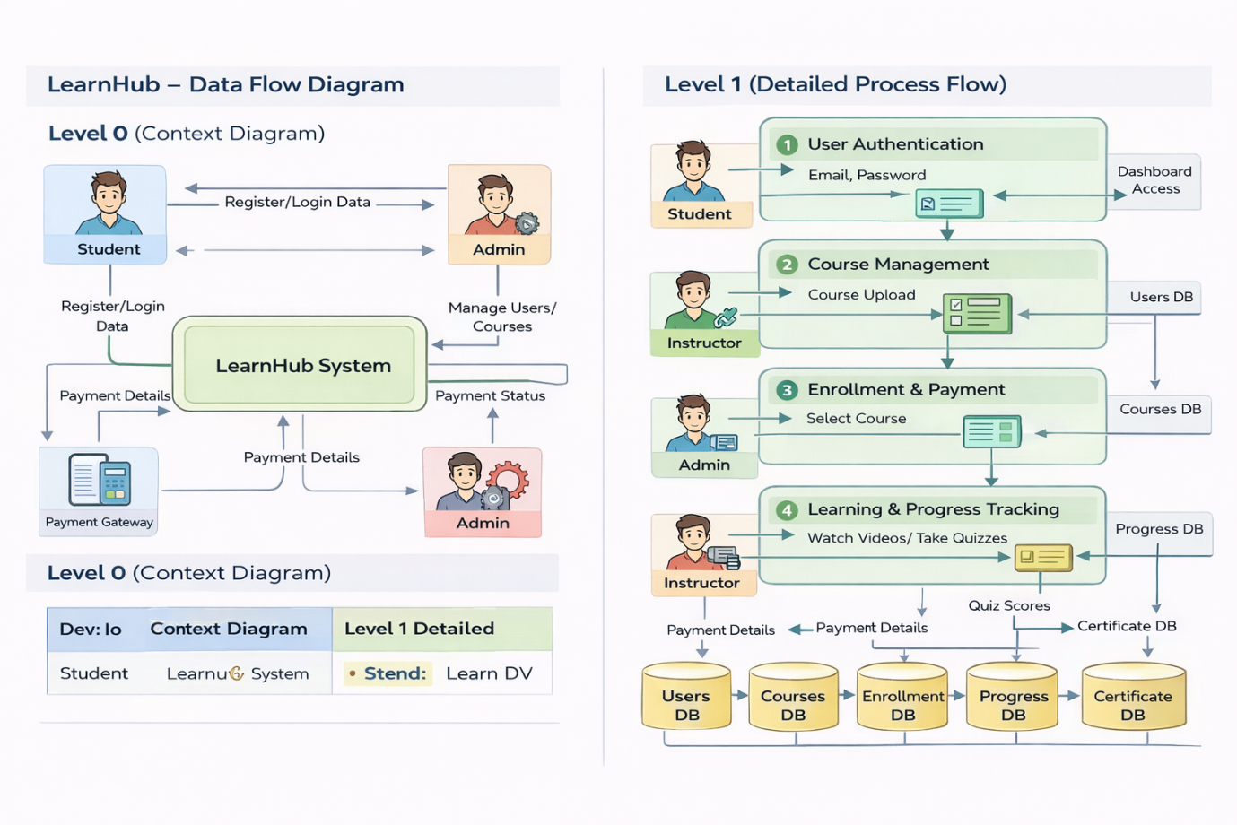

**User Stories**

| **User Type** | **Functional Requirement (Epic)** | **User Story Number** | **User Story / Task** | **Acceptance criteria** | **Priority** | **Release** |
| --- | --- | --- | --- | --- | --- | --- |
| Customer (Web User) | Registration | USN-1 | |  | | --- | |  |  |  | | --- | | As a user, I can register using email and  password | | Account created & dashboard accessible | High | Sprint-1 |
| Customer (Web User) | Authentication | USN-2 | As a user, I can log in securely | Successful login redirects to dashboard | High | Sprint-1 |
| Customer (Web User) | Course Listing | USN-3 | As a user, I can view available courses | Course list loads from database | High | Sprint-1 |
| Customer (Web User) | Enrollment Booking | USN-4 | As a student, I can book enrollment with date & time | Enrollment status shows “Pending” | High | Sprint-2 |
| Customer (Web User) | Document Upload | USN-5 | As a user, I can upload learning documents during enrolling | File uploads successfully | Medium | Sprint-2 |
| Course | Enrollment Management | USN-6 | As a course, I can accept or reject enrollment requests | Status updates to Scheduled/Rejected | High | Sprint-3 |
| Administrator | Course Approval | USN-7 | As an admin, I can approve course registrations | Approved course visible in system | High | Sprint-3 |
| Customer Care Executive | Notifications | USN-8 | As a user, I receive enrollment updates | Notification displayed in dashboard | Medium | Sprint-4 |
| Customer (Web User) | Enrollment History | USN-9 | As a user, I can view enrolling history | Previous enrollments visible | Medium | Sprint-5 |

**3.4 Technology Stack: -**

**Technical Architecture: -**

The LearnHub application follows a 3-Tier Client–Server Architecture:

* Presentation Layer (Frontend): React.js web interface where users, courses, and admins interact with the system.
* Application Layer (Backend): Node.js and Express.js handle API requests, authentication, enrollment processing, and role-based access control.
* Data Layer (Database): MongoDB stores user profiles, course details, enrollment records, and notifications.

The frontend communicates with backend REST APIs using Axios, while JWT authentication secures protected routes. File uploads such as learning documents are handled through Multer middleware.

**Table-1: Components & Technologies:**

|  |  |  |  |
| --- | --- | --- | --- |
| **S. No** | **Component** | **Description** | **Technology** |
|  | User Interface | Web interface for students, courses, and admin dashboards | React.js, HTML, CSS, Bootstrap, Material UI |
|  | Application Logic-1 | Authentication & Role Management | Node.js, Express.js, JWT |
|  | Application Logic-2 | Enrollment Booking & Scheduling | Express.js REST APIs |
|  | Application Logic-3 | Notification & Status Management | Node.js Controllers |
|  | Database | Stores users, courses, enrollments data | MongoDB, Mongoose |
|  | Cloud Database | Cloud-hosted NoSQL database for storing users, courses, enrollments, and notifications with remote access and scalability | MongoDB Atlas |
|  | File Storage | Medical document upload & storage | IBM Block Storage or Other Storage Service or Local Filesystem |
|  | External API-1 | |  | | --- | |  |  |  | | --- | | HTTP communication between frontend & backend | | Axios |
|  | External API-2 | Not Applicable | __ |
|  | Machine Learning Model | Not used in this project | __ |
|  | Infrastructure (Server / Cloud) | Local development deployment | Node.js Local Server |

**Table-2: Application Characteristics:**

| **S. No** | **Characteristics** | **Description** | **Technology** |
| --- | --- | --- | --- |
|  | Open-Source Frameworks | Frameworks used to build UI & Backend APIs | React.js, Express.js, Node.js |
|  | Security Implementations | Role-based authentication, encrypted passwords, protected routes | JWT, bcryptjs, Middleware |
|  | Scalable Architecture | 3-Tier architecture separating UI, backend logic, and database | REST Architecture, MongoDB |
|  | Availability | |  | | --- | |  |  |  | | --- | | Web application accessible anytime through browser | | Node.js Server |
|  | Performance | Fast API responses and asynchronous communication | Axios, Express.js |

**4. PROJECT DESIGN**

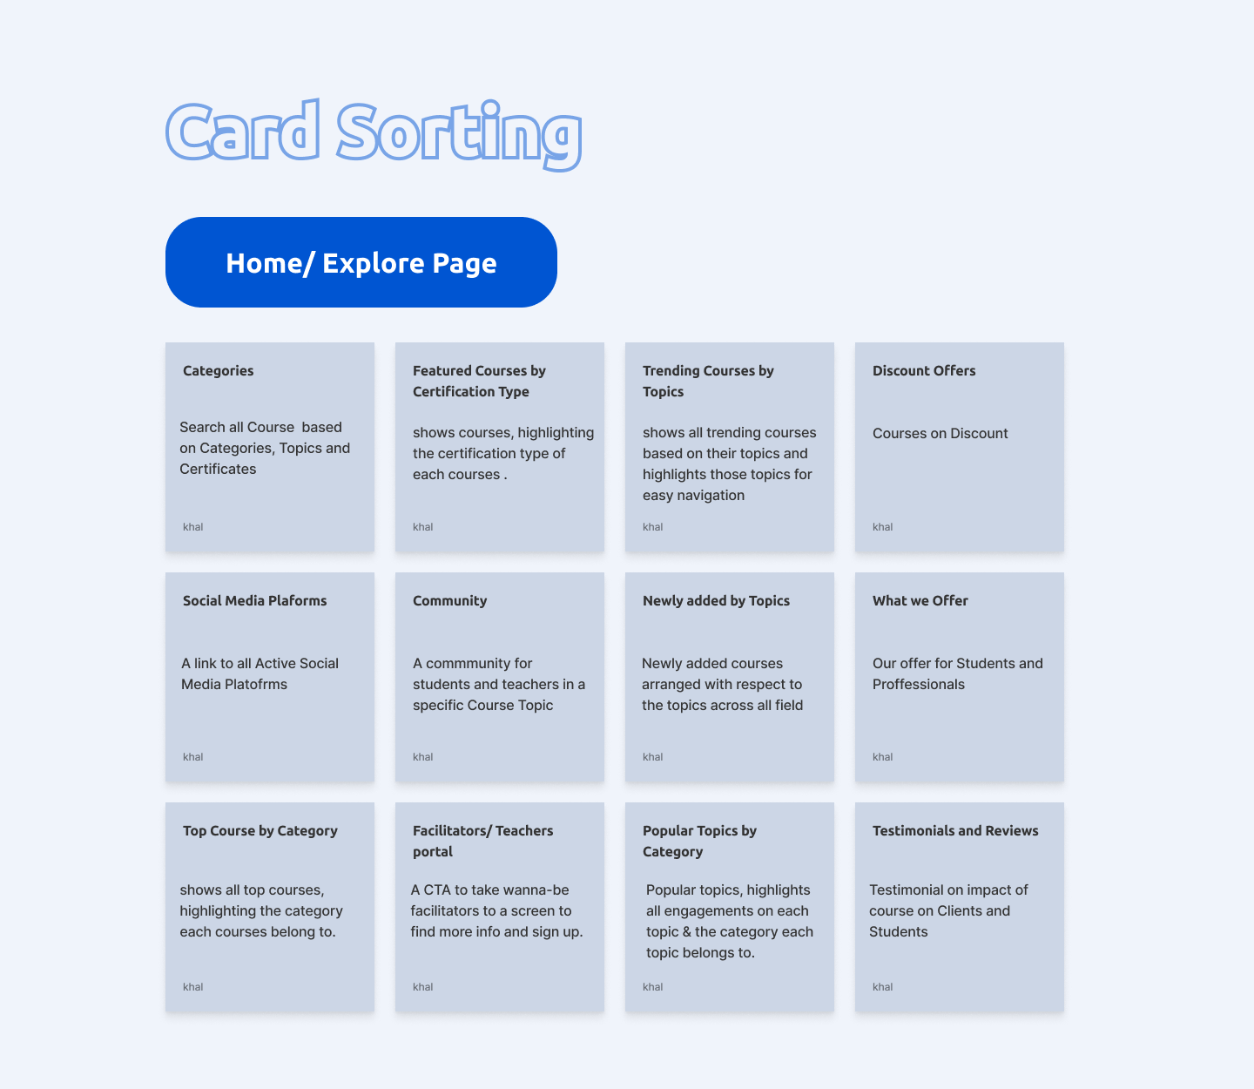**4.1 Problem Solution Fit:**

**4.2 Proposed Solution:**

|  |  |  |
| --- | --- | --- |
| **S.No.** | **Parameter** | **Description** |
|  | Problem Statement (Problem to be solved) | Students face difficulty enrolling course enrollments due to manual scheduling, lack of real-time availability, and long waiting times. Courses need a centralized platform to manage enrollments efficiently, while admins require a secure system to verify courses and maintain platform trust. |
|  | Idea / Solution description | LearnHub is a MERN-stack web application that enables students to book enrollments online through a centralized system. It provides role-based dashboards for Admin, Course, and User, real-time enrolling, secure JWT authentication, document upload, and enrollment status tracking using REST APIs connected to MongoDB Atlas. |
|  | Novelty / Uniqueness | Role-based healthcare workflow, admin-controlled course approval, real-time enrollment tracking, secure learning document upload, and a simplified user-friendly enrolling interface. |
|  | Social Impact / Customer Satisfaction | Reduces waiting time, improves healthcare accessibility, ensures verified course interactions, and enhances student convenience through digital enrollment management. |
|  | Business Model (Revenue Model) | Commission-based enrolling model, subscription plans for courses, premium course listing, and future telemedicine learning session services. |
|  | Scalability of the Solution | Built using 3-tier architecture (React frontend, Express backend, MongoDB Atlas cloud database), enabling scalable performance and easy expansion to support more users and healthcare services. |

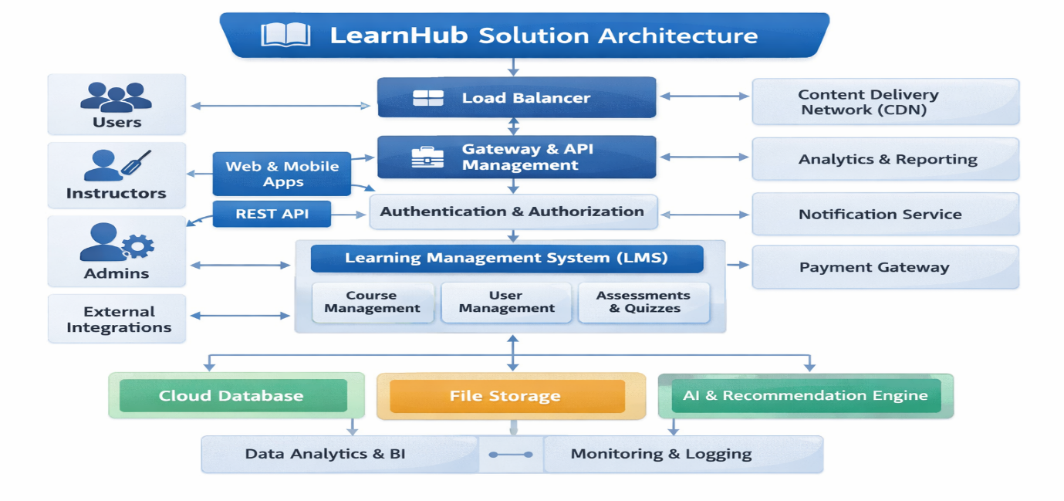**4.3 Solution Architecture:**

Figure-1: Architecture and data flow of the LearnHub course enrollment enrolling platform

**5. PROJECT PLANNING & SCHEDULING**

**5.1 Project Planning:**

**Product Backlog, Sprint Schedule, and Estimation :**

| **Sprint** | **Functional Requirement (Epic)** | **User Story Number** | **User Story / Task** | **Story Points** | **Priority** | **Team Members** |
| --- | --- | --- | --- | --- | --- | --- |
| Sprint-1 | Registration | USN-1 | |  | | --- | |  |  |  | | --- | | As a user, I can register using email and password | | 2 | High | Team |
| Sprint-1 | Authentication | USN-2 | As a user, I can log in securely using JWT authentication | 2 | High | Team |
| Sprint-1 | Dashboard | USN-3 | As a user, I can view course list on dashboard | 3 | High | Team |
| Sprint-2 | Enrollment Booking | USN-4 | |  | | --- | |  |  |  | | --- | | As a patient, I can book an appointment with date & time | | 5 | High | Team |
| Sprint-2 | Document Upload | USN-5 | As a user, I can upload learning documents during enrolling | 3 | Medium | Team |
| Sprint-3 | Course Panel | USN-6 | As a course, I can accept or reject enrollment requests | 5 | High | Team |
| Sprint-3 | Admin Panel | USN-7 | As an admin, I can approve course registrations | 4 | High | Team |
| Sprint-4 | Notifications | USN-8 | As a user, I receive enrollment status updates | 3 | Medium | Team |
| Sprint-4 | Enrollment History | USN-9 | As a user, I can view and manage enrolling history | 3 | Medium | Team |

**Project Tracker, Velocity & Burndown Chart:**

| **Sprint** | **Total Story Points** | **Duration** | **Sprint Start Date** | **Sprint End Date (Planned)** | **Story Points Completed (as on Planned End Date)** | **Sprint Release Date (Actual)** |
| --- | --- | --- | --- | --- | --- | --- |
| Sprint-1 | 15 | 4 Days | 01 Feb 2025 | 04 Feb 2025 | 15 | 04 Feb 2025 |
| Sprint-2 | 16 | 4 Days | 05 Feb 2025 | 08 Feb 2025 | 16 | 08 Feb 2025 |
| Sprint-3 | 14 | 4 Days | 09 Feb 2025 | 12 Feb 2025 | 14 | 12 Feb 2025 |
| Sprint-4 | 12 | 3 Days | 13 Feb 2025 | 15 Feb 2025 | 12 | 15 Feb 2025 |

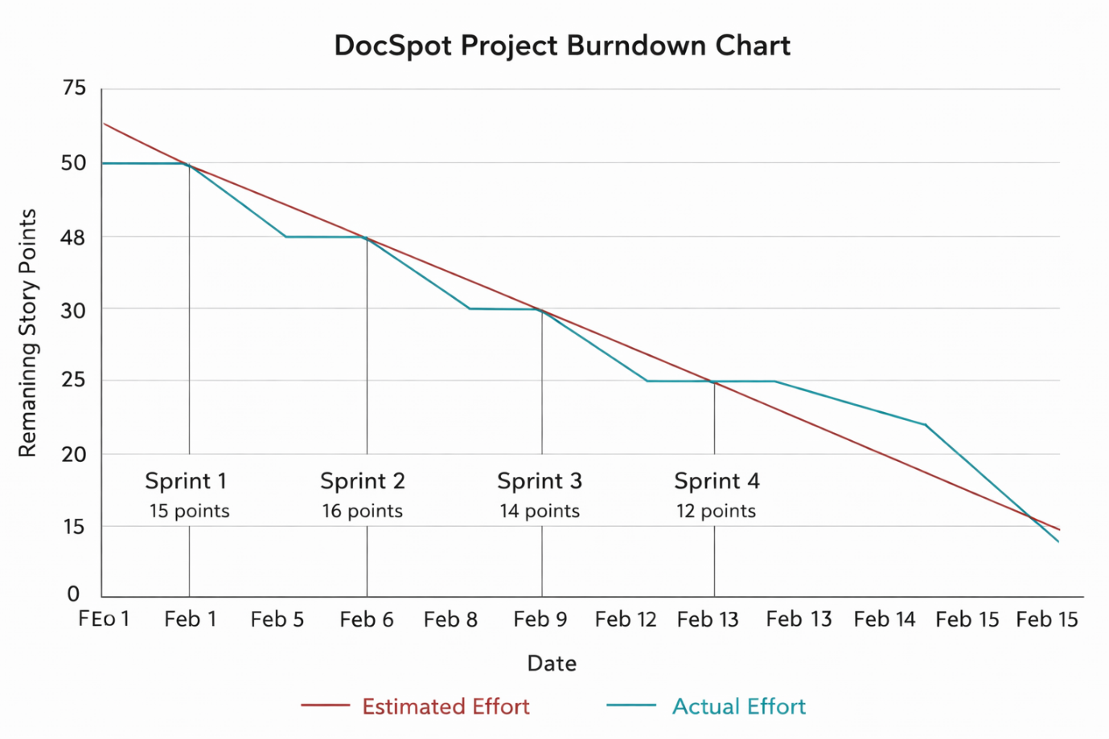

**6. FUNCTIONAL AND PERFORMANCE TESTING**

**6.1 Performance Testing:**

**Project Overview:**

Project Name: LearnHub: Seamless Enrollment Booking for Health

Project Description: LearnHub is a MERN-stack web application that enables students to book course enrollments online with real-time availability. The platform provides role-based dashboards for Admin, Course, and User, secure JWT authentication, document upload, and enrollment status tracking using MongoDB Atlas.

Project Version: v1.0

Testing Period: 12 Feb 2025 to 15 Feb 2025

**Testing Scope:**

**Features Tested:**

* User Registration & Login
* Role-based Dashboard
* Enrollment Booking
* Course Approval Workflow
* Document Upload
* Enrollment Status Notifications

**User Stories Tested:**

* USN-1 Registration
* USN-2 Login
* USN-4 Enrollment Booking
* USN-6 Course Approval
* USN-8 Notifications

**Testing Environment:**

URL/Location: http://localhost:5173

Credentials (if required): User → testuser@gmail.com / ******  
Course → doctest@gmail.com / ******  
Admin → admin@gmail.com / ******

**Test Cases:**

|  |  |  |  |  |  |
| --- | --- | --- | --- | --- | --- |
| **Test Case ID** | **Test Scenario** | **Test Steps** | **Expected Result** | **Actual Result** | **Pass/Fail** |
| TC-001 | User Registration | Step1: Open Register Page  Step2: Enter details Step3: Submit | User account created successfully | Account created | Pass |
| TC-002 | User Login | Step1: Enter email & password  Step2: Click Login | Redirect to dashboard | Dashboard loaded | Pass |
| TC-003 | View Courses | Step1: Login  Step2: Open Dashboard | Course list displayed | Courses visible | Pass |
| TC-004 | Book Enrollment | Step1: Select course Step2: Choose date Step3: Submit | Enrollment request created | Enrollment pending | Pass |
| TC-005 | Upload Document | Step1: Attach file during enrolling | File uploaded successfully | File stored | Pass |
| TC-006 | Course Approval | Step1: Admin approves course | Course status updated | Approved successfully | Pass |
| TC-007 | Enrollment Status Update | Step1: Course accepts request | Status changes to Scheduled | Status updated | Pass |

**Bug Tracking:**

|  |  |  |  |  |  |
| --- | --- | --- | --- | --- | --- |
| **Bug ID** | **Bug Description** | **Steps to reproduce** | **Severity** | **Status** | **Additional feedback** |
| BG-001 | Minor UI alignment issue in dashboard | Step-1: Login  Step-2: Open Dashboard | Low | Closed | Fixed using CSS update |
| BG-002 | File upload delay on slow internet | Upload large file | Medium | In Progress | Optimization suggested |

**Sign-off:**

Tester Name: Bharath Munakala

Date: 15 February 2025

Signature: Bharath Munakala

**7. RESULTS**

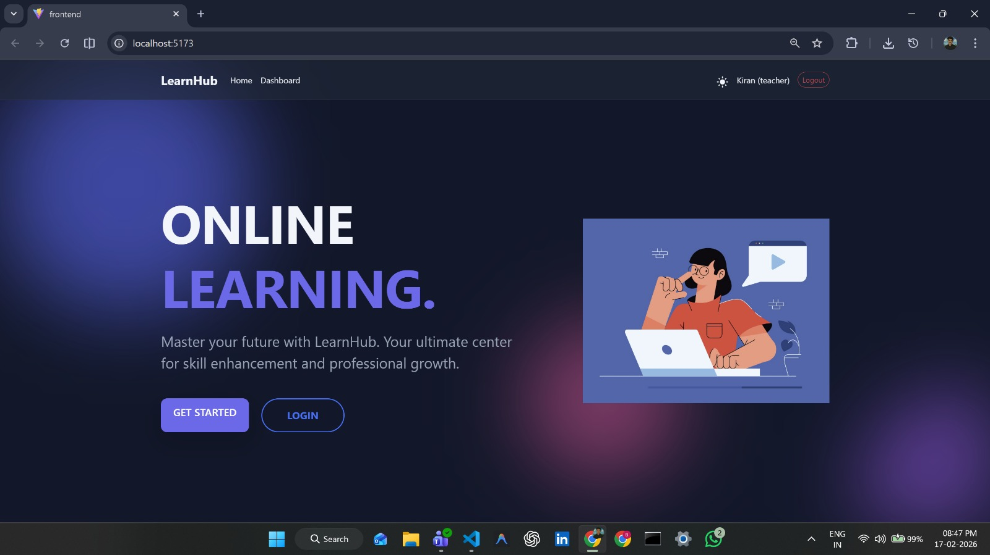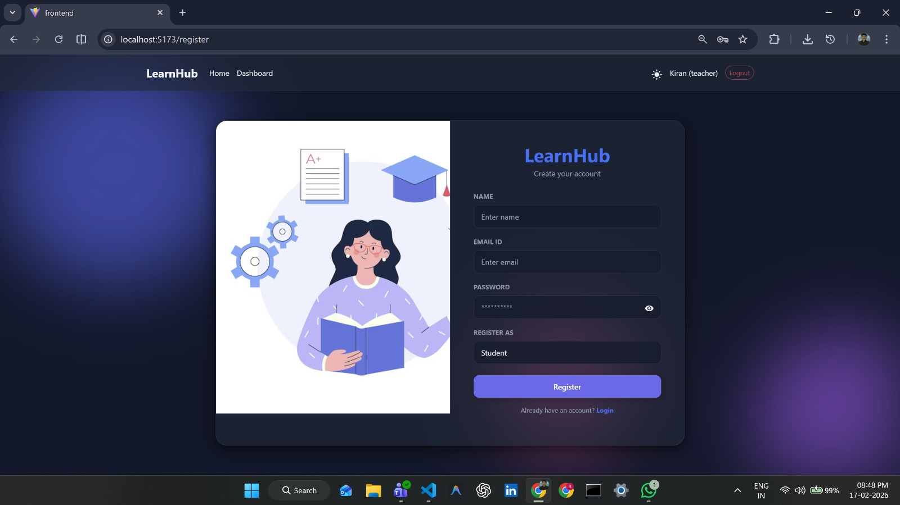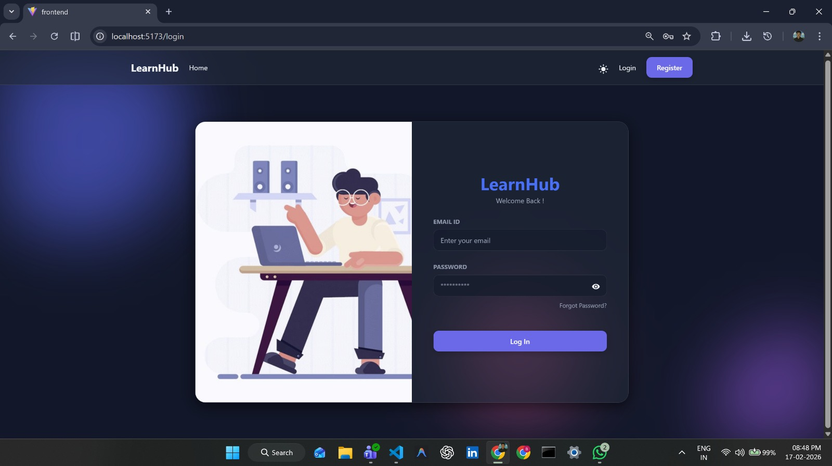**7.1 Output Screenshots:**

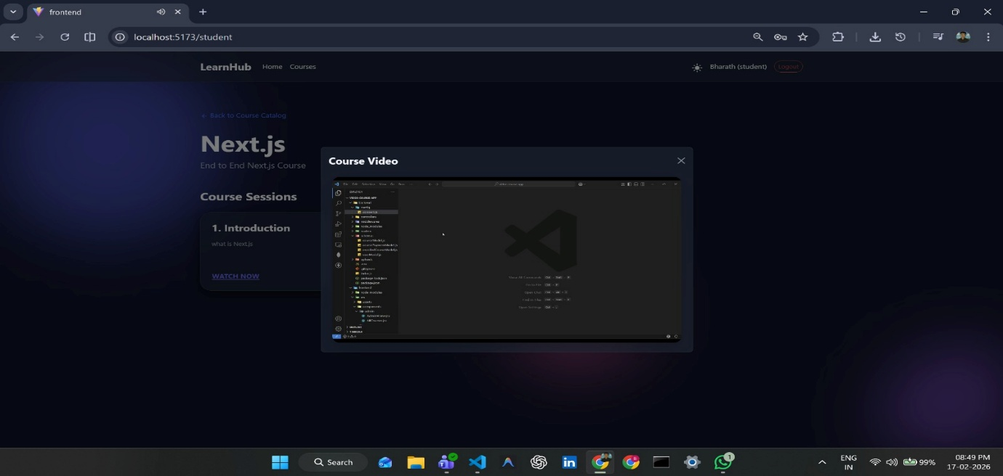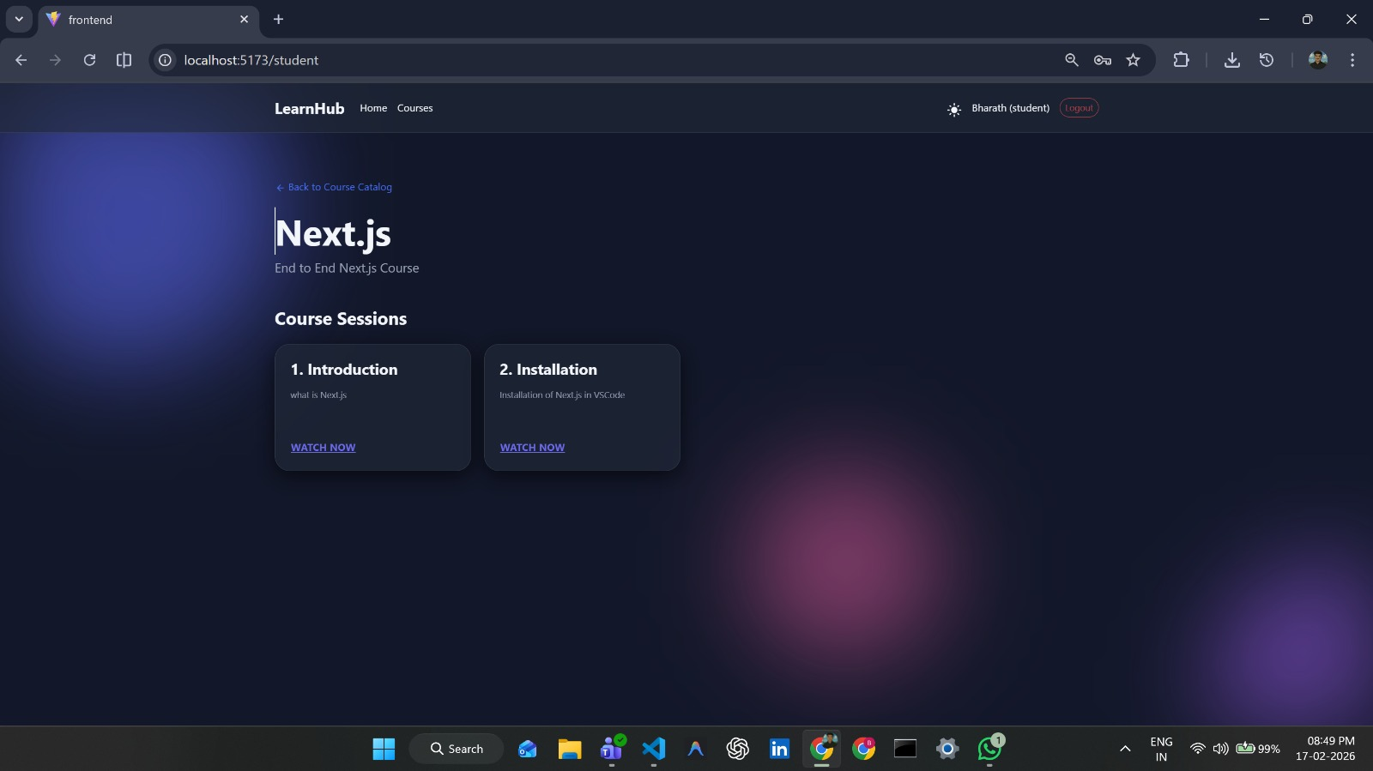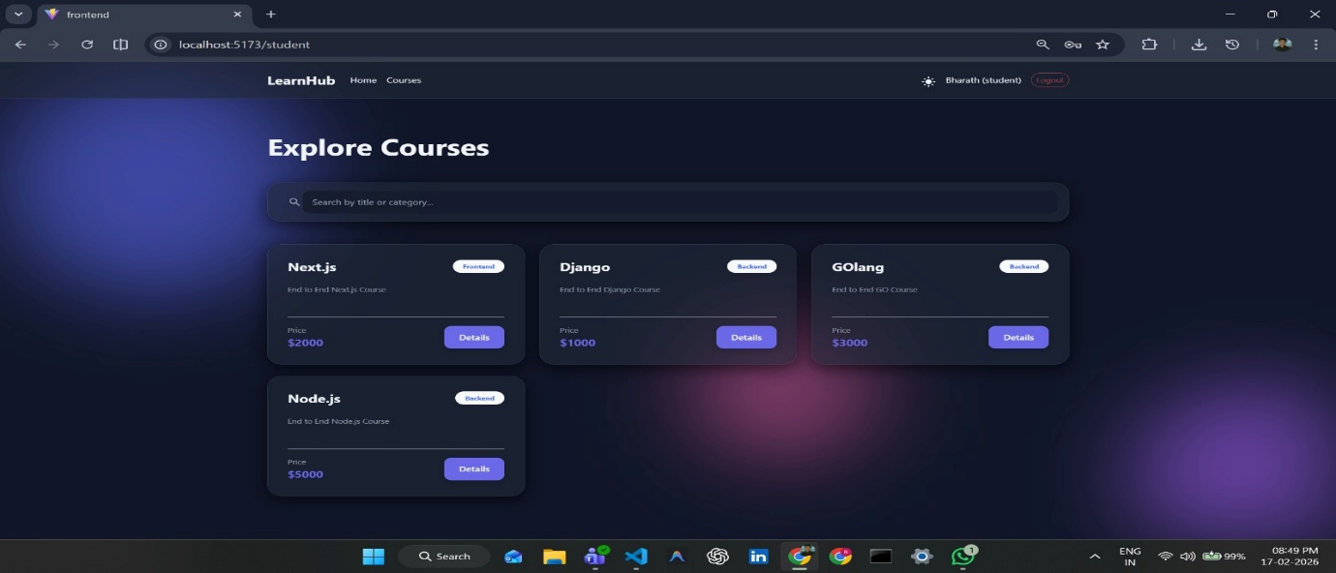

**8. ADVANTAGES & DISADVANTAGES**

**Advantages**

* Real-Time Enrollment Booking: Students can view available courses and book enrollments instantly, reducing manual delays.
* Role-Based Access Control: Separate dashboards for Admin, Course, and User improve workflow management.
* **Cloud Database Integration:** Using MongoDB Atlas ensures scalability, data security, and remote access.
* **Secure Authentication:** JWT-based login protects user data and restricts unauthorized access.
* Digital Document Management: Students can upload learning records during enrolling, improving learning session efficiency.
* **User-Friendly Interface:** Built with React and modern UI libraries for smooth interaction.

**Disadvantages**

* Requires stable internet connectivity to access the platform.
* File upload performance may depend on network speed.
* Currently supports only web-based access (no mobile app).
* Real-time notifications may require further optimization.

**9. CONCLUSION**

The LearnHub Course Enrollment Booking Platform successfully addresses the challenges of traditional healthcare scheduling by providing a centralized digital solution. Through the use of modern web technologies such as React.js, Node.js, Express.js, and MongoDB Atlas, the system enables seamless interaction between students, courses, and administrators.

The platform improves healthcare accessibility by reducing waiting time, enabling efficient enrollment management, and ensuring secure handling of learning data. The project demonstrates practical implementation of full-stack development concepts, RESTful APIs, authentication mechanisms, and cloud database integration.

**10. FUTURE SCOPE**

* Integration of video learning session for telemedicine services.
* Mobile application development using React Native.
* AI-based course recommendation system.
* Real-time push notifications using WebSockets or Firebase.
* Payment gateway integration for online learning session fees.
* Advanced analytics dashboard for courses and administrators.
* Automated enrollment reminders via SMS or Email.

1. **APPENDIX**

**GitHub Repository:**

<https://github.com/Bharath8080/LearnHUB> **Live Demo / Project Video:**

<https://drive.google.com/file/d/1sV0bSRbgEKLlSMttn7lJ5rpqfHFhMwiu/view?usp=sharing>